

Mini Project Report - 04

Master of Computer Application – General
Semester – I

Sub: Frontend Frameworks and Technologies

Topic: Semantic Department Website
By
Name: Ashraj Singh Rana
Reg no.: PROV/ASAC/MCA/7/26/058

Faculty Name: VEERA RAGHAV K

Faculty Signature: _______________

Department of Computer Application
Alliance University
Chandapura - Anekal Main Road, Anekal
Bengaluru - 562 106
August 2025

INDEX
Fig No. | Name | Page No.
 | Introduction | 1
 | Input code | 2 16
 | Output code | 17 -18
 | Conclusion | 19

INTRODUCTION
The semantic department website is a responsive web-based project developed using HTML and CSS to provide structured and organized information about academic department. The website is designed using HTML5 semantic elements such as <header>, <nav>, <main>, <section>, <article>, <aside> and <footer> to demonstrate the proper structure and organization of a modern web page. The website includes various sections and pages such as Home, About department, faculty, courses, timetable, achievements, events, and contact. It provides information about the department’s vision, mission, objective, faculty members, courses, semester-wise subjects, class and contact details. HTML5 is used to structure the content semantically, while CSS is used to create the visual design, including colours, typography, spacing, navigation menu, card, tables, buttons, and responsive layouts. The project demonstrates the practical implementation of semantic HTML5 and front-end web development concepts while creating a user- friendly and responsive department website.

INPUT CODE
<!DOCTYPE html>
<html lang="en">
<head>
<meta charset="UTF-8">
<meta name="viewport" content="width=device-width, initial-scale=1.0">
<title>Semantic Department Website</title>
<style>
* {
margin: 0;
padding: 0;
box-sizing: border-box;
}

body {
font-family: Arial, sans-serif;
background-color: #f4f9f8;
color: #222;
line-height: 1.6;
}

header {
background-color: #6ee7c1;
padding: 25px 20px;
text-align: center;
}

h1 {
font-size: 36px;
margin-bottom: 15px;
}

nav ul {
list-style: none;
display: flex;
justify-content: center;
flex-wrap: wrap;
gap: 15px;
}

nav ul li {
background-color: #dffaf2;
padding: 8px 12px;
border-radius: 5px;
font-weight: bold;
}

section {
width: 90%;
margin: 25px auto;
background-color: #ffffff;
padding: 25px;
border-radius: 10px;
box-shadow: 0 2px 8px rgba(0,0,0,0.08);
}

h2 {
text-align: center;
color: #b31217;
margin-bottom: 20px;
}

p {
font-size: 18px;
text-align: center;
margin-bottom: 15px;
}

.gallery {
display: flex;
justify-content: space-evenly;
flex-wrap: wrap;
margin: 20px 0;
}

.gallery img {
width: 200px;
height: 150px;
object-fit: cover;
border: 3px solid #222;
border-radius: 8px;
}

.highlights {
display: flex;
justify-content: space-evenly;
flex-wrap: wrap;
gap: 50px;
margin-top: 15px;
}

.highlights div {
background-color: #6ee7c1;
color: white;
padding: 12px 18px;
border-radius: 5px;
font-weight: bold;
}

.cards {
display: flex;
justify-content: center;
flex-wrap: wrap;
gap: 20px;
}

.card {
width: 260px;
background-color: #f2fbf8;
border: 1px solid #d9d9d9;
border-radius: 10px;
padding: 20px;
text-align: center;
}

.card h3 {
color: #0a7a5d;
margin-bottom: 10px;
}

table {
width: 100%;
border-collapse: collapse;
margin-top: 20px;
}

th, td {
border: 1px solid #ccc;
padding: 10px;
text-align: center;
}

th {
background-color: #6ee7c1;
color: #000;
}

ul {
padding-left: 25px;
}

form {
width: 100%;
max-width: 500px;
margin: 0 auto;
}

label {
display: block;
margin-top: 12px;
font-weight: bold;
}

input, textarea {
width: 100%;
padding: 10px;
margin-top: 5px;
border: 1px solid #bbb;
border-radius: 5px;
}

button {
margin-top: 15px;
padding: 10px 18px;
background-color: #1ca77d;
color: white;
border: none;
border-radius: 5px;
cursor: pointer;
}

footer {
background-color: #1d1d1d;
color: white;
text-align: center;
padding: 18px;
margin-top: 30px;
}
</style>
</head>
<body>
<header>
<h1>Department of Computer Applications</h1>
<nav>
<ul>
<li>Home</li>
<li>About Department</li>
<li>Faculty</li>
<li>Courses</li>
<li>Timetable</li>
<li>Achievements</li>
<li>Events</li>
<li>Contact</li>
</ul>
</nav>
</header>

<main>
<section>
<p>
The Master of Computer Applications (MCA) program with specializations in Data Science,
General, Generative AI, and Game Designing is designed to deliver advanced computing knowledge
along with domain-specific expertise aligned to emerging industry trends.
</p>
<p>
The program follows a comprehensive, application-driven approach, enabling students to build
strong conceptual understanding and practical proficiency in core areas such as programming,
data structures, algorithms, database management systems, cloud computing, and software engineering.
</p>

<marquee>
<h2>Dear MCA Graduates, Welcome! to AU</h2>
</marquee>

<h2>Highlights</h2>
<div class="gallery">
<img src="./elchinator-security-5043368.jpg.jpeg" alt="Security">
<img src="./geralt-artificial-intelligence-4389372.jpg.jpeg" alt="AI">
<img src="./paulos-ai-8330457.jpg.jpeg" alt="AI 2">
<img src="./sunriseforever-game-console-6603120.jpg.jpeg" alt="Game Design">
</div>

<div class="highlights">
<div>Generative AI</div>
<div>Data Science</div>
<div>Game Designing</div>
<div>Cybersecurity</div>
</div>
</section>

<section>
<h2>About Department</h2>
<div class="cards">
<div class="card">
<h3>Vision</h3>
<p>To create a vibrant environment that encourages innovation and leadership in technology.</p>
</div>
<div class="card">
<h3>Mission</h3>
<p>To provide quality education and practical learning in computer applications.</p>
</div>
<div class="card">
<h3>Objectives</h3>
<p>To build analytical thinking, creativity, and industry-ready skills in students.</p>
</div>
</div>
</section>

<section>
<h2>Faculty</h2>
<div class="cards">
<div class="card">
<h3>Dr. Ananya Rao</h3>
<p>HOD & Professor</p>
<p>Data Structures, AI, DBMS</p>
</div>
<div class="card">
<h3>Prof. Sandeep Kumar</h3>
<p>Associate Professor</p>
<p>Java, OOP, Software Engineering</p>
</div>
<div class="card">
<h3>Prof. Meena Iyer</h3>
<p>Assistant Professor</p>
<p>Python, Data Science</p>
</div>
<div class="card">
<h3>Mr. Arjun Singh</h3>
<p>Assistant Professor</p>
<p>Web Development, Cloud Computing</p>
</div>
</div>
</section>

<section>
<h2>Courses</h2>
<div class="cards">
<div class="card">
<h3>Semester 1</h3>
<ul>
<li>Problem Solving Using C</li>
<li>Discrete Mathematics</li>
<li>Computer Organization</li>
</ul>
</div>
<div class="card">
<h3>Semester 2</h3>
<ul>
<li>Data Structures</li>
<li>DBMS</li>
<li>Operating Systems</li>
</ul>
</div>
<div class="card">
<h3>Semester 3</h3>
<ul>
<li>Java Programming</li>
<li>Web Technologies</li>
<li>Software Engineering</li>
</ul>
</div>
</div>
</section>

<section>
<h2>Timetable</h2>
<table>
<tr>
<th>Day</th>
<th>9:00-10:00</th>
<th>10:15-11:15</th>
<th>11:30-12:30</th>
<th>1:30-2:30</th>
</tr>
<tr>
<td>Monday</td>
<td>Data Structures</td>
<td>DBMS</td>
<td>Java</td>
<td>Web Lab</td>
</tr>
<tr>
<td>Tuesday</td>
<td>Python</td>
<td>OS</td>
<td>Networks</td>
<td>Python Lab</td>
</tr>
<tr>
<td>Wednesday</td>
<td>AI</td>
<td>Software Engineering</td>
<td>Web Technologies</td>
<td>DBMS Lab</td>
</tr>
<tr>
<td>Thursday</td>
<td>Cloud Computing</td>
<td>Algorithms</td>
<td>Research</td>
<td>Java Lab</td>
</tr>
</table>
</section>

<section>
<h2>Achievements</h2>
<div class="cards">
<div class="card">
<h3>Student Achievements</h3>
<ul>
<li>Top ranks in university exams</li>
<li>Hackathon winners</li>
<li>Placement in top IT companies</li>
</ul>
</div>
<div class="card">
<h3>Faculty Achievements</h3>
<ul>
<li>Research publications</li>
<li>Workshops conducted</li>
<li>Mentoring student startups</li>
</ul>
</div>
</div>
</section>

<section>
<h2>Events</h2>
<div class="cards">
<div class="card">
<h3>Workshops</h3>
<ul>
<li>AI Workshop</li>
<li>Web Development Bootcamp</li>
</ul>
</div>
<div class="card">
<h3>Seminars</h3>
<ul>
<li>Data Science Trends</li>
<li>Cloud and DevOps</li>
</ul>
</div>
<div class="card">
<h3>Hackathons</h3>
<ul>
<li>Code Sprint</li>
<li>AI for Social Good</li>
</ul>
</div>
</div>
</section>

<section>
<h2>Contact</h2>
<div class="card" style="margin: 0 auto; max-width: 600px;">
<p><strong>Department Address:</strong> Aurora University, Hyderabad</p>
<p><strong>Email:</strong> mca@aurora.edu</p>
<p><strong>Phone:</strong> +91 98765 43210</p>
</div>

<form>
<label>Name</label>
<input type="text" placeholder="Enter your name">

<label>Email</label>
<input type="email" placeholder="Enter your email">

<label>Message</label>
<textarea placeholder="Write your message"></textarea>

<button type="submit">Send Message</button>
</form>
</section>
</main>

</body>
</html>

OUTPUT

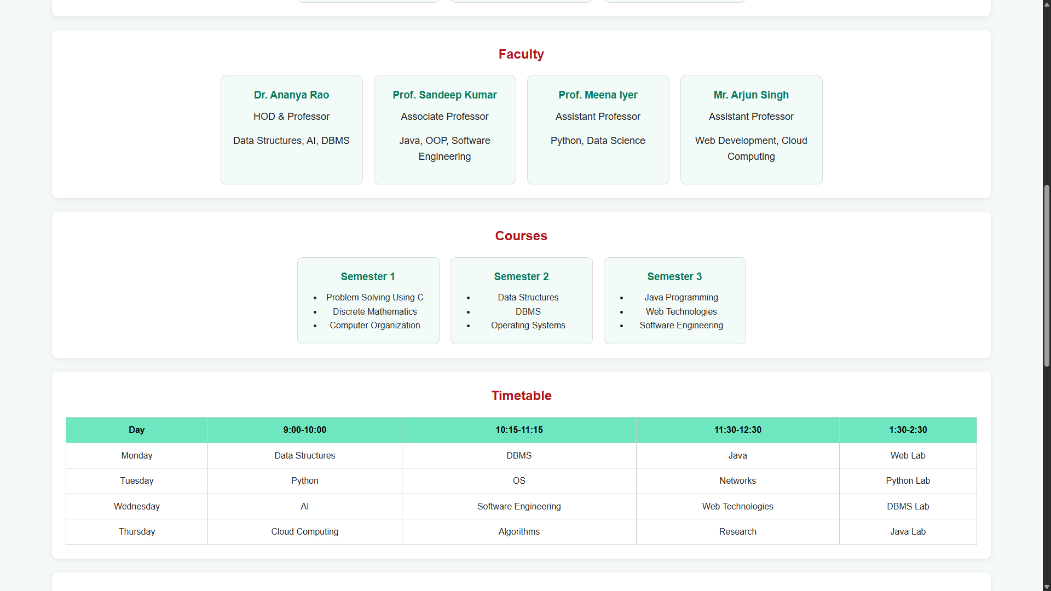
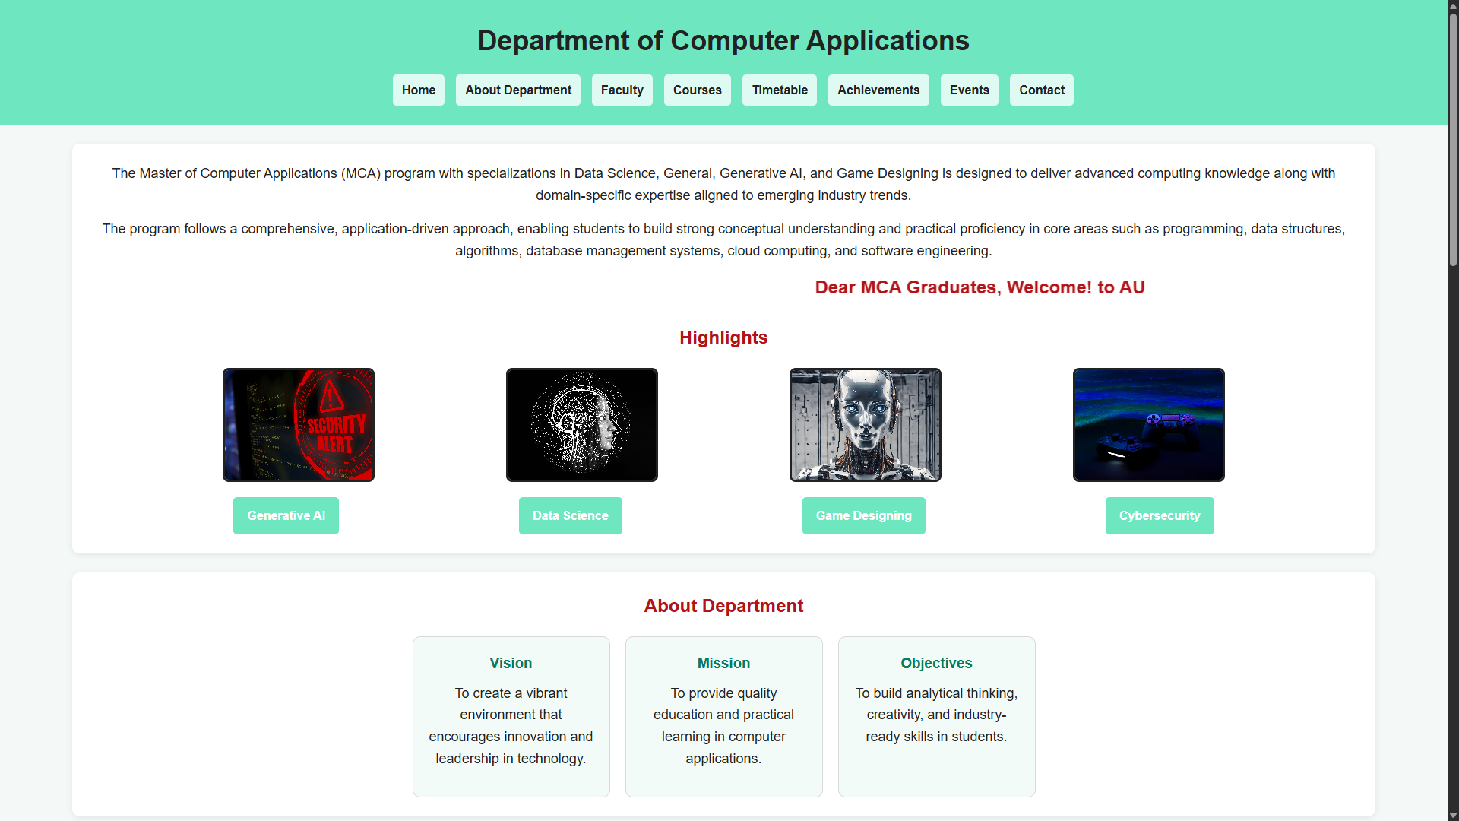
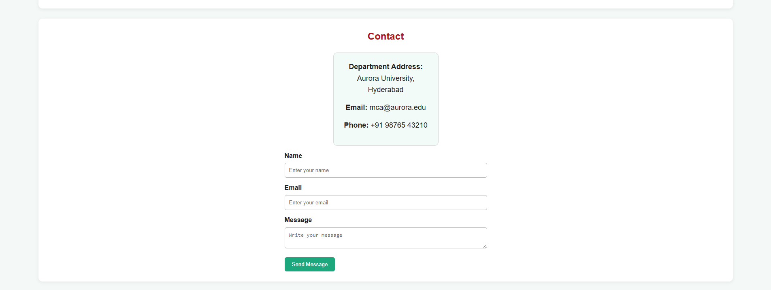
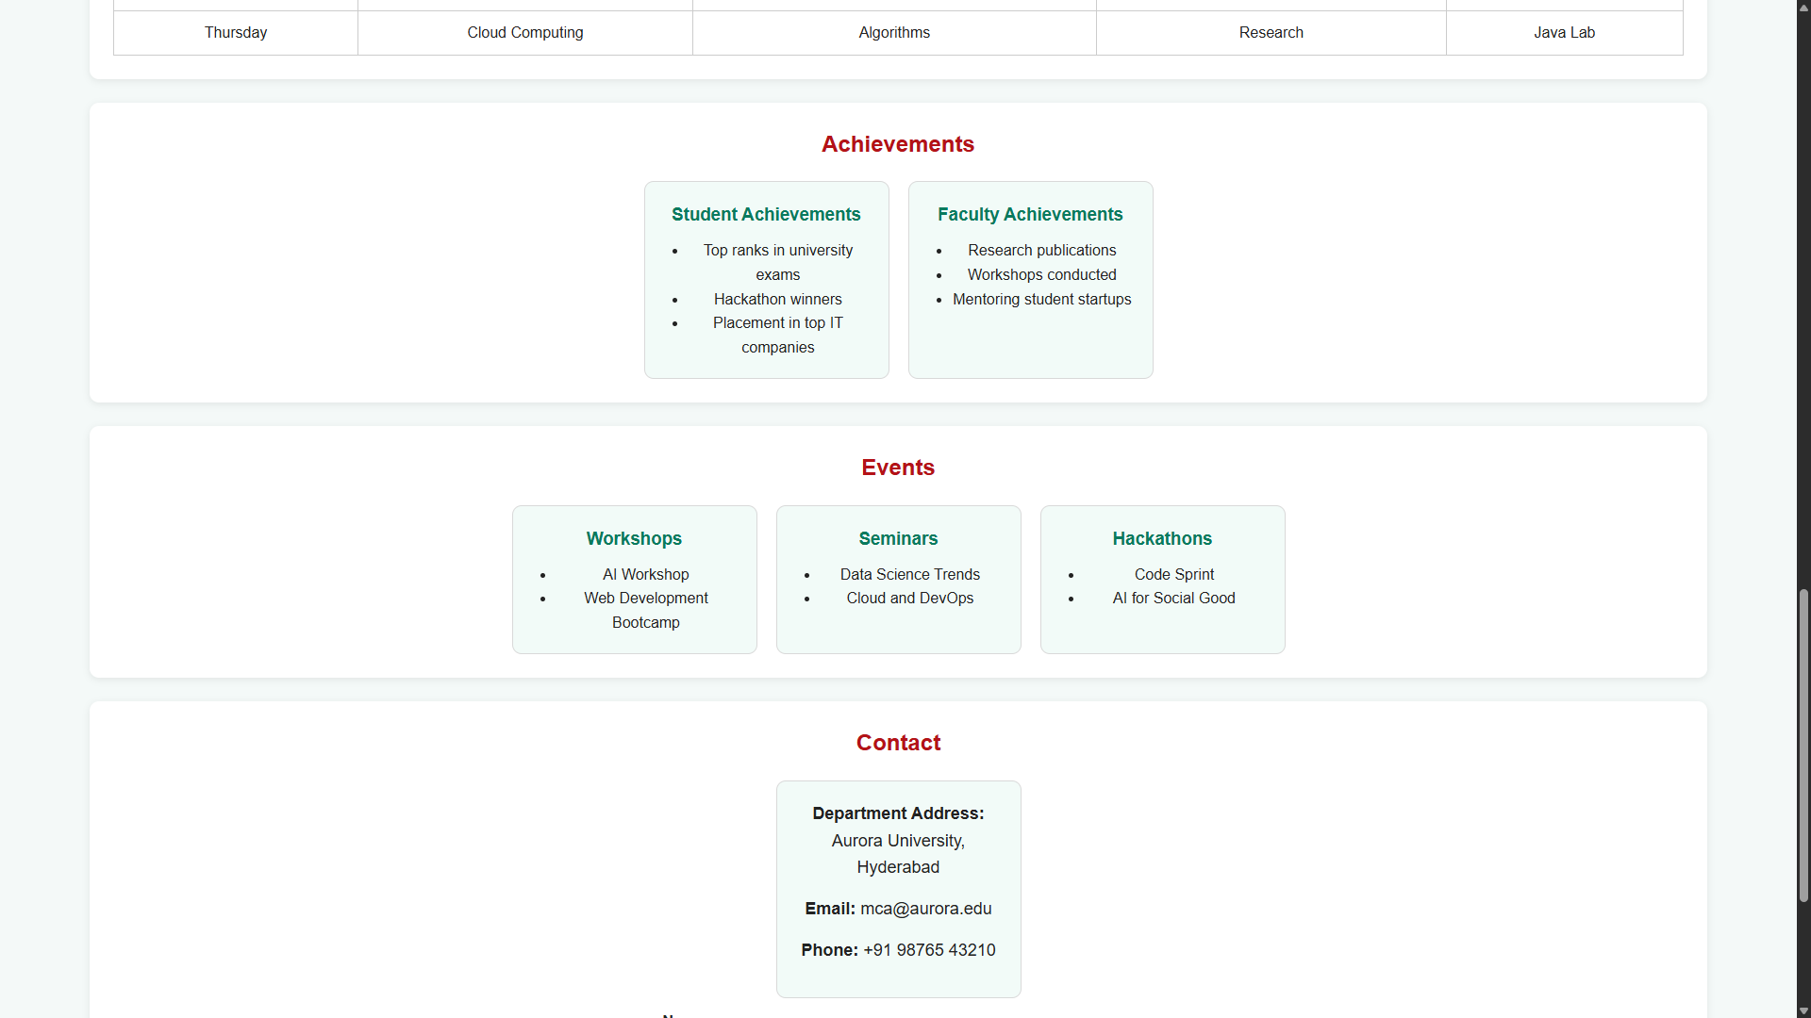
CONCLUSION
The semantic department website successfully demonstrates the practical implementation of HTML5 semantic elements to create a well- structured and organized departmental website. The website effectively presents important information such as department details, vision, mission, objective, faculty members, courses, timetables, achievements, events, and contact information in a clear and user-friendly manner. The use of semantic HTML elements improves the structure, readability, and accessibility of the web pages, while CSS provides an attractive and responsive, organizing web content, designing responsive layouts, and professional website for an academic department.

